PILS 2021 Executive
Nomination Kit

● President
● VP (Internal)
● VP (Academic)
● VP (External)
● VP (Finance)
● VP (Fundraising)
● VP (Communications)
● Two U2 Representatives
● Two U3 Representatives

Please read all information in this package and fill out the necessary form. Please contact elise.vanleer@mail.mcgill.ca with questions.

Dear candidate,

As Chief Electoral Officer, I would like to welcome you to the 2021 Pharmacology Integrative League of Students (PILS) Executive Elections! PILS represents the voice of all Pharmacology students within the McGill community. The executive members provide events and services for Pharmacology students, and elections for these positions are held annually. The positions available are: President, Vice-President (Academic), Vice-President (Communications), Vice-President (External), Vice-President (Finance), Vice-President (Fundraising), Vice-President (Internal), two U2 Representatives, and two U3 Representatives. A short description of each position is provided in this nomination kit. Note that you may run for only one position.

In this package, you will find a nomination list. Those applying for the position of PILS President require seventy-five (75) signatures from pharmacology students. Candidates applying for other PILS positions require fifty (50) signatures from pharmacology students. Please note that while signatures are usually collected in-person, this year we will be collecting them online using Google Forms. Pharmacology students refer to current McGill University students enrolled in the pharmacology major or honours program. Current U0 students who intend on entering the major are not eligible to nominate a candidate or run for a position. One student may nominate more than one candidate.

You must return the completed nomination package by emailing it directly to elise.vanleer@mail.mcgill.ca. You must submit it by 23:59 on Monday, March 15, 2021; if the form is received late, you will not be considered a candidate.

If an executive position is uncontested by 23:59 on Monday, March 15, 2021, the nomination period will be extended by 48 hours for such a position (to Wednesday, March 17th). Campaigning period will begin at 00:01 on Monday, March 22, 2021. Campaigning outside the campaign period is strictly prohibited. Campaign rules can be found in this nomination package.

Only full-time pharmacology majors or honours students are eligible to run for positions on PILS.

Sincerely,
Elise Van Leer

DATES

Nomination period:
Monday, March 8 (00:01) – Monday, March 15 (23:59)
- For any non-contested positions, the nomination period will extend to Wednesday, March 17th

Campaign period:
Monday, March 22 (00:01) - Friday, March 26 (23:59)
A question-and-answer session for all candidates will be held on Friday, March 26th from 4-5 PM. All pharmacology students are welcome. Candidate attendance is mandatory.

Meeting details
Topic: PILS Town Hall for 2021 Candidates
Time: Mar 26, 2021 04:00 PM America/Toronto
Join Zoom Meeting
https://mcgill.zoom.us/j/89777233029
Meeting ID: 897 7723 3029

Polling period:
Saturday, March 28th (00:01) – Tuesday, March 31st (23:59)

CAMPAIGNING RULES
- No campaign material (including internet campaigning) may refer to another candidates’ position, or be offensive to any person, organization, or department.
- Lecture recordings may be reviewed for offensive campaign material
- Internet campaigning is permitted.
- Mass emails are prohibited
- Posts made in non-election-related Facebook groups are prohibited
- Campaigning in libraries is prohibited.
- Candidates must include the following on all posters or Social Media pages (note: previously campaigning has been restricted to Facebook, but this year we have opened all platforms to campaigning):
- The email of the Chief Electoral Officer (elise.vanleer@mail.mcgill.ca)
- Polling dates (Saturday, March 28th (00:01) – Tuesday, March 31st (23:59)
- The words: “Pharmacology Integrative League of Students” or “PILS”
- Candidates may NOT use the PILS logo
- Any Facebook events must end by 23:59 on Friday, March 26
- No current executive member of PILS may publicly support a candidate, with the exception of joining Facebook Events pages.
- It is not acceptable for a current executive member of PILS to change his/her profile-picture to support a candidate.
- If a current executive member chooses to join a candidate’s Facebook group or event page, they must additionally accept all requests made my all candidates to join respective group- or event-pages.
- Current executive members must cease all duties pertaining to their current position during their campaign.
- Candidates may campaign in any class only with the permission of the course instructor.
- Campaigning shall end at 23:59 on Friday, March 26. All campaigning material must be taken down by this time, including campaign-related posts on the Internet. Campaigning outside of the campaign period is strictly prohibited.

Violation of campaign rules before or after polling period is grounds for immediate disqualification.

Should a violation of campaign rules be discovered after the polling period, the Chief Electoral Officer and current non-campaigning executive members will organize another election for the position in question.

Information Regarding the Executive Positions:

PRESIDENT
The PILS president is responsible for enforcing the constitution and by-laws of PILS and ensuring its long-term integrity in addition to acting as the chief PILS representative in cooperation with the VP External. The president must chair and coordinate the activities and Council meetings, set the agenda, and ensure that the objectives of PILS are met as the Chief Executive Officer. In addition, the president serves as the Chief Electoral Officer (if not running).

VICE PRESIDENT (ACADEMIC)
The PILS VP Academic provides for PILS academic affairs by planning and coordinating academic events and activities, advising Council on academic policy and services, and chairing the Academic Committee. He/she cooperates with the SUS VP Academic to promote McGill academic policy enhancement.

VICE PRESIDENT (COMMUNICATIONS)
The PILS VP Communications is responsible for facilitating communication between Council members by taking Minutes of Council meetings and maintaining both the PILS listserv and website. The VP Communications must provide for the marketing and publicity of PILS’ affairs.

VICE PRESIDENT (EXTERNAL)
The PILS VP External is responsible for representing PILS to external bodies and agencies in cooperation with the President. The VP External must coordinate and organize events and activities with the VP Internal, secure sponsorships and revenue with the VP Finance, and co-chair the Planning Committee. Should the President resign or be removed, the VP External shall assume Presidential duties until a by-election.

VICE PRESIDENT (FINANCE)
The PILS VP Finance is responsible for ensuring the long-term financial stability of PILS, advising Council on financial policy, maintaining and preparing PILS’ financial records, developing the annual budget, and operating the finances of the association with the consent of Council.

VICE PRESIDENT (FUNDRAISING)
The PILS VP Fundraising is responsible for ensuring the success of fundraising initiatives by planning, coordinating, and organizing PILS fundraising activities to provide financial stability in cooperation with the VP Finance.

VICE PRESIDENT (INTERNAL)
The PILS VP Internal is responsible for ensuring good rapport between PILS and its memberships by planning, coordinating, and organizing PILS events and activities with the VP External, co-chairing the Planning Committee, and advising Council on the membership opinions.

U2 REPRESENTATIVES
The PILS U2 Representatives serve as advocates for U2 Pharmacology students to the PILS Council and are responsible for certain communications between these students as well as for organizing U2-specific NTCs.

U3 REPRESENTATIVES
The PILS U3 Representatives serve as advocates for U3 Pharmacology students to the PILS Council and are responsible for certain communications between these students as well as for organizing U3-specific NTCs.

Instructions for getting nomination signatures:

1. Click this link: https://docs.google.com/forms/d/1xlMGPPPlF-HNEULQBmRFeMaYgYxeOOuwZ5j4HiJqAaU/edit?usp=sharing

DO NOT MAKE ANY EDITS TO THE TEMPLATE. YOU WILL NEED TO MAKE A COPY OF THIS TEMPLATE. I WILL BE NOTIFIED OF ANY EDITS TO THE DOCUMENT.

2. Make sure you are signed into your google account/Gmail.

3. Click the three vertical dots as indicated in the photo below.

4. Click “Make a copy”. This option will be unavailable if you are not already logged into your Gmail account.

5. You will receive the following prompt:
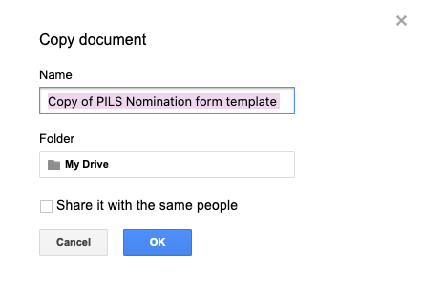

Rename your file [YOUR NAME] Nomination Form 2021 and click OK.

6 . This form should now open and is also available in your Google Drive. Ensure that all of the following fields are on the form: Name (first and last), student number, E-signature, program, year

7. Modify the information in the description of the Google Form with your name and the position you will be running for.
********DO NOT ADD ANY INFORMATION TO THIS DESCRIPTION**********

8. Once you have filled in your name and position, you are ready to distribute your form! Click the purple “send” button in the upper right-hand corner of the page.

Click the (-) icon to generate a link that you can send to fellow pharmacology students! They will be able to “sign” the form once you send them this link.

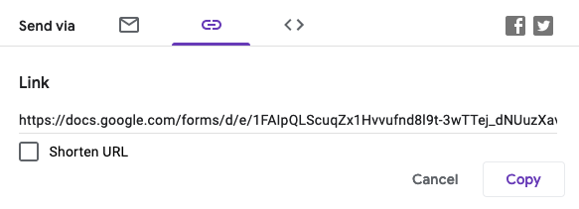

Number of responses can be monitored in the “Responses” tab at the top of the form.

9. Once you have collected your required number of responses, click the green CREATE SPREADSHEET button under the “Responses” tab.

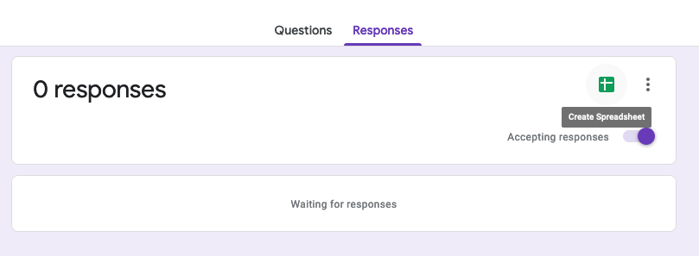

You will see the following prompt:
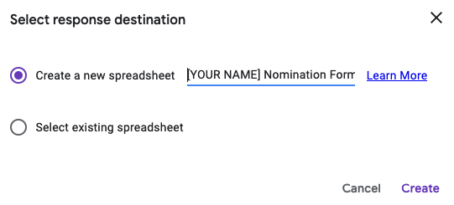

Create a new spreadsheet and name it [YOUR NAME] Nomination Form. Click Create.
A new form will open as an Excel sheet with all responses.

Once the sheet has opened, click FILE then hover over EMAIL, then click Email this file. Please send to elise.vanleer@mail.mcgill as specified below.
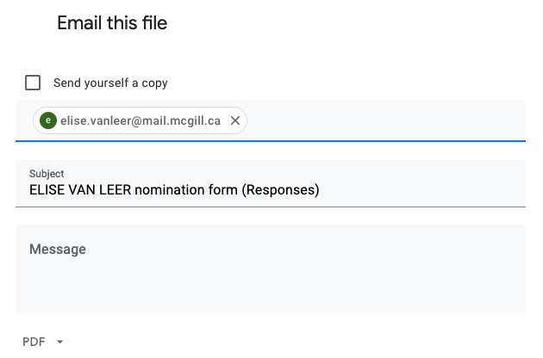
You can also download it as a .xls and send it to me that way if you prefer.

IF YOU HAVE ANY PROBLEMS COMPLETING ANY STEP, DO NOT HESITATE TO EMAIL ELISE.VANLEER@MAIL.MCGILL.CA

You must email me the signature form, along with this page. You must send it to elise.vanleer@mail.mcgill.ca by Monday, March 15 (23:59). Nomination forms received after this time will not be considered for approval.

If the candidate should choose to write a brief (max. 200 words) statement to be sent to all Pharmacology students at the beginning of the Campaigning period (optional), please write it below in the space provided. A photo of the candidate is encouraged and may accompany the brief statement and should be sent by e-mail to the Chief Electoral Officer in JPEG format.

[YOUR PERSONAL STATEMENT HERE]

I have read and understood all documentation found within this nomination package and hereby swear that I have collected and verified the authenticity of each signature to the best of my ability.

Name of Candidate (printed):

Student number:

Signature of Candidate:

Date:

Contact Information (don’t worry, this information will only be used by the Chief Electoral Officer if she needs to reach you)

Email address:

Phone number:

Signature of Chief Electoral Officer:
Date:

